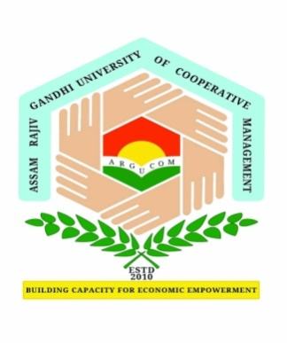
Assam Rajiv Gandhi University of Cooperative Management
A Govt. of Assam University
Recognised by UGC and member of Association of Indian Universities
Email: info.argucom@gmail.com; Phone: 03772-222144
RUCM/Acad/PhD Prelim Regd/__/21/ Date:

Details of Provisional Registration for PhD

- Name:

- School:

- Department:

- Area of research:

- Date of provisional registration:

- Details of fees payment:

- Details of Assigned Guide:

- Name:

- Designation:

- Address:

- Phone No.:

- Mobile No.:

- Email id:

Verified by HOD (i/c) Signature of Dean (i/c)
School of ______________________ ARGUCOM

